**Non-Targeted Analysis Method Reporting Tool**

**Instructions for Use**

**Summary**

The Non-Targeted Analysis (NTA) Method Reporting Tool is a macro-enabled Microsoft Excel workbook that allows for the controlled ontology of method data reporting and the export of the data into a single concise, human-readable file, written in a standard JavaScript Object Notation (JSON).

**File Descriptions**

NTA Method Report Tool.xlsm – the base file that can be used to create a new method reporting file.

NTA Method Reporting Tool_example.xlsm – an example file with completed information.

**Instructions**

1. Open the NTA Method Report Tool.xlsm, you may have to select “Enable Macros”

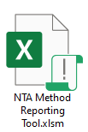

1. Upon opening, you will be prompted to save the Excel Workbook as a separate file. This file can be saved and edited later prior to exporting the data, so it is recommended to save different files for each individual datafile. Click **Save** to continue.

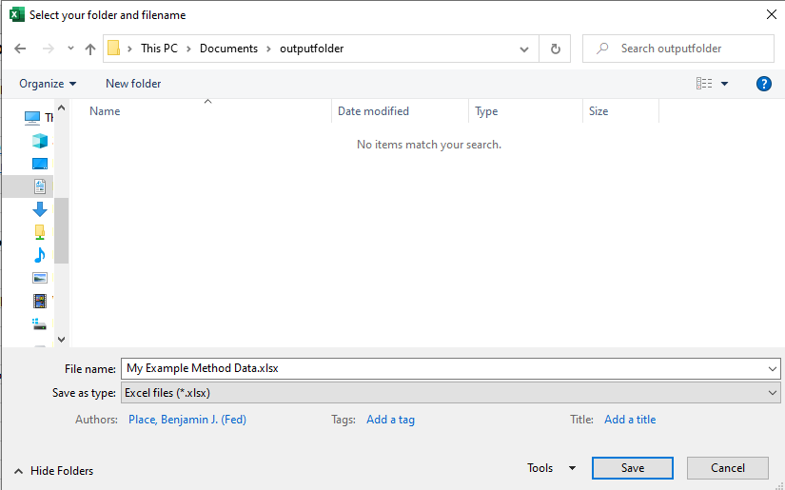

1. The first sheet (titled **Run**) shows the steps for filling out the Method Reporting Tool. This sheet will also tell you if you have completed the minimum amount of information for each section.

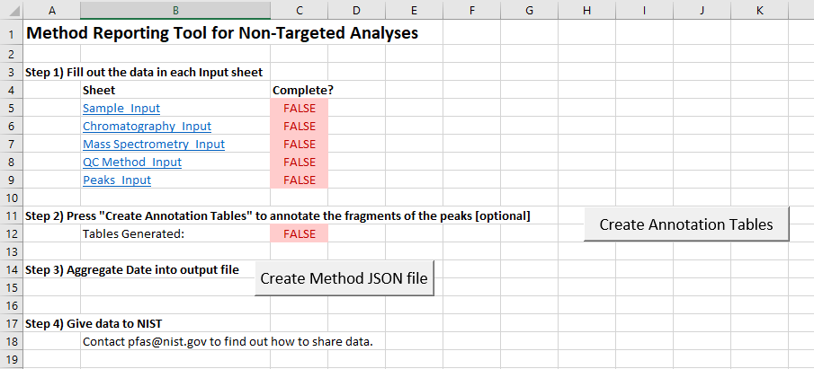

1. For each section, there is information to fill out under the **Values** heading. For those values that have restricted inputs, there is a drop-down menu.
   1. If there is not an appropriate item in the drop-down menu, contact Ben Place at [benjamin.place@nist.gov](mailto:benjamin.place@nist.gov) with the recommended changes and they will update the form.

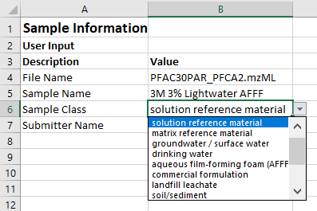

* 1. When you select a specific value cell, hover text will appear and describe the type of input expected for the value.

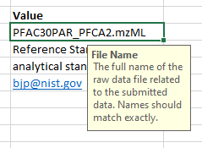

1. The following information is provided for each individual input sheet

**Sheet:** Sample_Input

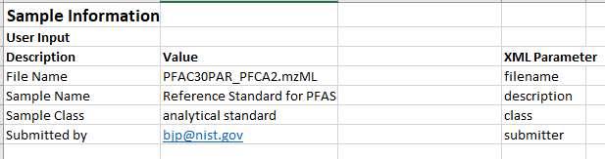

*File Name*: The name of the raw data file to be submitted, can be an mzML or proprietary data format. Names should match exactly.

*Sample Name*: name of the sample as described by the user, uncontrolled.

*Sample Class*: the category or class to which the sample belongs.

Examples: analytical standard, landfill leachate

*Submitter Name*: Unique identifier for submitting user or laboratory. For individual users, use email address.

**Sheet:** Chromatography_Input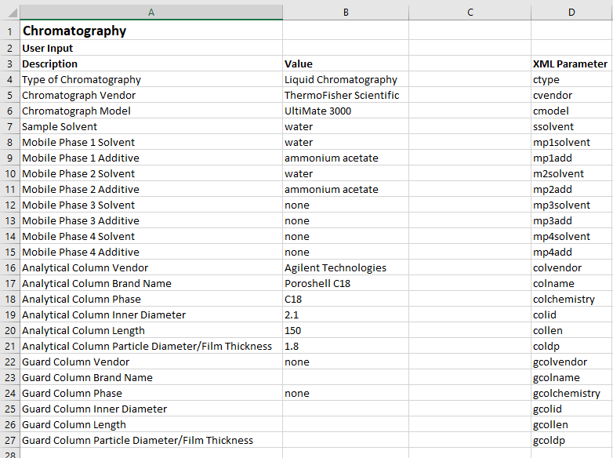

*Type of Chromatography:* the type of chromatography used for the generation of the data.

Options: liquid chromatography (LC), gas chromatography (GC), capillary electrophoresis (CE), or none

*Chromatograph Vendor:* the manufacturer or vendor of the chromatograph

Options: most common chromatograph vendors

*Chromatograph Model:* the model name of the chromatograph

Example: UltiMate 3000, Agilent 1260, Waters 2695

*Sample Solvent:* the primary solvent of the sample, as injected

Options: most common solvents

Example: if sample solvent is 30 % water, 69 % methanol, and 1 % formic acid, the primary solvent is methanol

*Mobile Phase Solvent 1/2/3/4:* the primary solvent used for the mobile phase program, allowing for up to a quaternary pump. Select ‘none’ if not used in program.

Options: most common solvents.

Example: if Mobile Phase 1 (A) is 95 % water, 4.9 % acetonitrile, and 0.1 % formic acid, the primary solvent is water

*Mobile Phase Additive 1/2/3/4:* the primary additive used in the respective solvent for the mobile phase program, allowing for up to a quaternary pump. Select ‘none’ if not used in program.

Options: most common additives

Example: if Mobile Phase 2 (B) is 95 % acetonitrile with water and 10 mM ammonium acetate, adjusted to pH 6 with ammonium hydroxide, the primary additive is ammonium acetate.

*Analytical/Guard Column Vendor:* the manufacturer of the analytical or guard chromatography column used for the experiment.

Options: most common column manufacturers

*Analytical/Guard Column Brand Name:* the commercial brand/product name of the analytical or guard chromatography column.

Examples: Halo C18, Eclipse Plus C18

*Analytical/Guard Column Phase:* the ligand chemistry of the stationary phase in the analytical or guard column.

Options: C18, C8, pentafluorophenyl (PFP), biphenyl, silica, mixed-phase, diol, pentadiol

Note: if the phase has more than one chemistry or multiple columns in sequence are used, select ‘mixed-phase’

*Analytical/Guard Column Inner Diameter/Length:* the dimensions of the analytical or guard column.

Note: for LC columns, report values in millimeters. For GC or CE columns, report values in micrometers.

*Analytical/Guard Column Particle Diameter/Film Thickness*: the particle diameter (LC) or the film thickness (GC, CE) of the analytical or guard column.

Note: for LC columns, report particle diameter in micrometers. For GC or CE columns, report film thickness in micrometers.

**Sheet:** Mass Spectrometry_Input

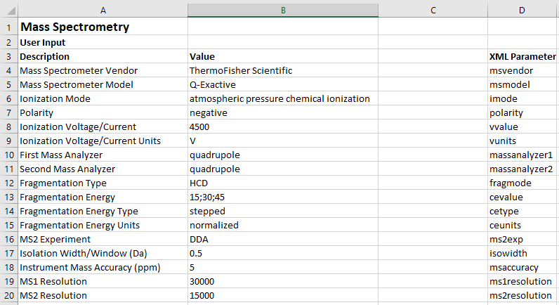

*Mass Spectrometer Vendor:* the manufacturer or vendor of the mass spectrometer

Options: most common mass spectrometer vendors

*Chromatograph Model:* the model name of the chromatograph

Example: Q-Exactive HF, Agilent 6550, Sciex X500

*Ionization Mode:* the type of ionization mechanism used with the mass spectrometer.

Options: atmospheric pressure chemical ionization, atmospheric pressure photoionization, electrospray ionization, electron ionization, chemical ionization

*Polarity:* the ionization polarity used for the compounds reported.

Options: positive, negative

Note: Only one polarity can be selected at a time. If polarity switched was used, the worksheet must be submitted twice (once for positive, once for negative).

*Ionization Voltage/Current:* the voltage or current applied for the ionization mode.

Note: Report number only, units will be selected in the next section.

*Ionization Voltage/Current Units:* the units for the reported value of ionization voltage/current.

Example: V, μA

*First Mass Analyzer:* the first mass analyzer of the mass spectrometer. If only one mass analyzer is used, then this is the only mass analyze used.

Options: quadrupole, linear ion-trap, magnetic sector, time-of-flight, orbitrap, fourier transform ion cyclotron resonance.

Example: for a QTOF instrument, the first mass analyzer is a quadrupole.

*Second Mass Analyzer:* the second mass analyzer of the mass spectrometer. If only one mass analyzer is used, then select ‘none’.

Options: quadrupole, linear ion-trap, magnetic sector, time-of-flight, orbitrap, fourier transform ion cyclotron resonance.

Example: for a LIT-Orbitrap, the second mass analyzer is an orbitrap.

*Fragmentation Type:* for the generation of fragment ions, report the type of fragmentation or collision cell used.

Options: high-energy collisional dissociation (HCD), collisionally-induced dissociation (CID), electron capture dissociation (ECD), in-source fragmentation

Note: For data using GC-EI-MS, select ‘in-source fragmentation’.

*Fragmentation Energy:* the energy value used for fragmentation. For stepped/ramped collision energy, separate levels by a semicolon (;). The type of fragmentation energy and units will be selected below.

*Fragmentation Energy Type:* the type of fragmentation energy used. For stepped/ramped collision energy, selected ‘stepped’. For all other types of fragmentation energy, select ‘fixed’.

*Fragmentation Energy Units:* the units of the reported energy value used for fragmentation.

Options: normalized, volts (V)

*MS2 Experiment:* the type of fragmentation (MS2) experiment used for generating fragment ions.

Options:

DDA: For data-dependent analysis, where a narrow window for a specific precursor ion is selected, including TopN and Information Dependent Acquisition (IDA).

SWATH: For sequential windowed-based precursor selection, including the Sequential Windows of All Theoretical Mass Spectra (SWATH) technique

DIA: For data-independent analysis, where no precursor ion is selected, including All Ion Fragmentation or MSE analysis.

none: if using in-source fragmentation

*Isolation Width/Window:* The isolation width or window for the precursor ion selection.

Note: for DDA, report the isolation width in Da. For SWATH, report the window width in Da. For DIA or none, leave blank.

*Instrument Mass Accuracy:* the mass accuracy of the instrument, reported in ppm.

Note: if you are not reporting data using high resolution mass spectrometry, enter 0.

*MS1 Resolution:* the resolution of the MS1 data.

*MS2 Resolution:* the resolution of the MS2 data. If no MS2 data, leave empty.

**Sheet:** QC Method_Input

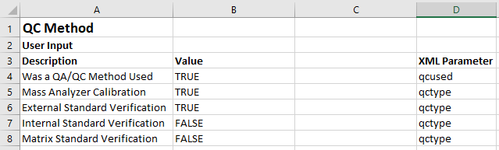

*Was a QA/QC Method Used?* If the user has established (internally or published) protocols for the quality assurance and/or quality control for the measurement of the submitted data, select TRUE.

Note: if your QA/QC protocol is not described in the below techniques, but you still used a QA/QC protocol, select TRUE.

*Mass Analyzer Calibration:* Was the mass analyzer used calibrated within the period specified by the manufacturer? If yes, select TRUE.

*External Standard Verification:* Was the quality of the instrumental method verified by the analysis of a solvent spiked with known chemical standards during the analytical sequence that produced the submitted data? If yes, select TRUE.

Example: an aliquot of methanol was spiked with perfluoroalkyl carboxylic acids and analyzed during the same sequence as the samples.

*Internal Standard Verification:* Was the quality of the instrumental method verified by the analysis of samples that have been enriched/spiked with known chemical standards? If yes, select TRUE.

Example: the sample was spiked with 13C-labeled perfluoroalkyl carboxylic acid standards prior to being analyzed.

*Matrix Standard Verification:* Was the quality of the instrumental method verified by the analysis of a control sample, which is a material consisting of a matrix similar to the unknown samples that contains known chemical compounds that are endogenous or enriched/spiked? If yes, select TRUE.

Example: a certified reference material of fish tissue extracted into methanol and analyzed during the same sequence as the samples.

**Sheet:** Peaks_Input

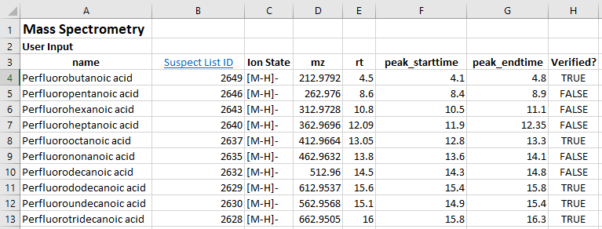

To submit mass spectra for identified compounds within a single raw data file, you must provide:

*Name:* name of the compound. This is an uncontrolled value and does not need to match the compound name in the NIST Suspect List.

*Suspect List ID:* the ID value for the compound in the NIST Suspect List of Possible Per- and Polyfluoroalkyl Substances (<https://data.nist.gov/od/id/mds2-2387>)

*Ion State*: the ion/adduct state of the precursor ion as it related to the measured *m/z* value for the specific compound.

*mz*: the measured m/z for the precursor ion used for the fragmentation of the compound, not the exact mass of the compound. For in-source fragmentation, this is *m/z* corresponding the molecular or pseudomolecular ion of the compound.

*rt:* the retention time of the chromatographic peak apex for the identified compound. This can be reported from most software, or can be approximated by the user.

*peak_starttime:* the retention time of the start of the chromatographic peak for the identified compound. This can be reported from most software, or can be approximated by the user.

*peak_endtime:* the retention time of the end of the chromatographic peak for the identified compound. This can be reported from most software, or can be approximated by the user.

*Verified?* If the compound identity was verified using a chemical standard, by matching the retention time, precursor *m/z* and/or fragmentation mass spectrum, select TRUE.

Note: if the sample is a chemical standard for the identified compound, select TRUE.

1. When the information is complete, return to the **Run** sheet.
   1. If you have peaks for which you want to annotate the fragments, go to step 7.
   2. If you have no peaks to annotate, go to step 9.
2. To annotate fragments, press the **Create Annotation Tables** button. 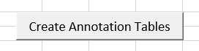

For each compound identified in the **Peaks_Input** sheet, a new sheet will be generated titled “Ann_[compound name]”.

1. For each compound, you will be able to submit annotated fragments for the fragmentation mass spectrum. Annotation is the attribution of the elemental formula (and structure, if possible) to a specific measured *m/z* of a fragment. All fragments within a mass spectrum do not need to be annotated. All compounds submitted with the dataset do not need to have annotated fragments.

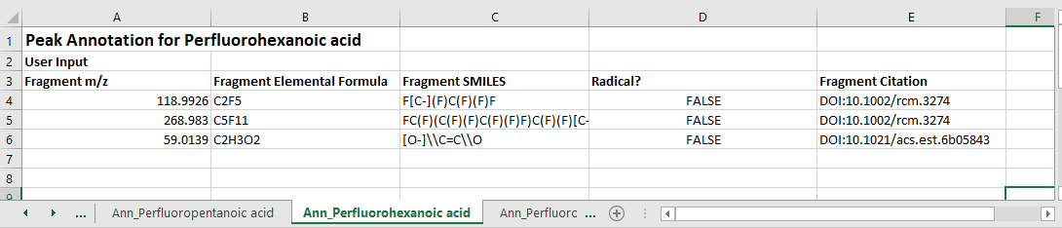

For each fragment for each compound, you can submit the following:

*Fragment m/z* – the measured *m/z* value for the fragment to-be-annotated (required)

*Fragment Elemental Formula* – the elemental formula attributed to the measured fragment *m/z* (required)

*Fragment SMILES* – the chemical structure (in SMILES notation) attributed to the measured fragment *m/z* (optional)

*Radical*?If the annotated fragment contains a radical electron, enter TRUE. If not, enter FALSE. If the existence of a radical electron cannot be determined, enter UNKNOWN.

*Fragment Citation* – the documented evidence of the elemental formula, structure, and/or radical for the measured fragment *m/z*.

Options:

DOI – if the evidence is listed in a published manuscript, enter the DOI with the format: DOI:number

Website: if the evidence is listed on a website, enter the URL with the format: <https://www.website.com/12345>

User interpretation: if the user interpreted the elemental formula, structure, or radical without supporting evidence, enter USER.

Note: If software was used to annotate the fragments, enter the software website or DOI as the citation. For example: <https://cfmid.wishartlab.com/>

1. When completed, check to make sure all parts of Step 1 are completed by going to the **Run** sheet.

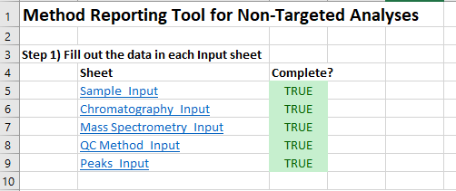

If all sheets have TRUE under complete, you can press **Create Method JSON File**



If successful, a pop-up message should notify you of the name of the new JSON file, which will be located in the same folder as the NTA Method Reporting Tool.xlsm file.

